A Project Report On
“Identifying IT Assets in a Network”
Submitted in partial fulfillment of the
Requirement for the Award of degree of
Bachelor of Technology
of
Sardar Vallabhai National Institute Of Technology,Surat



Compiled by:
Aanchal Handa(U16CO110)
Sardar Vallabhai National Institute Of Technology,Surat

Under the guidance of:
Mr. Navneet Raikwar
Manager(Prog.)
GEOPIC, ONGC, Dehradun

DECLARATION

I hereby declare that the work presented in this project report entitled
“Identifying IT Assets in a Network” in partial fulfillment of requirement for the Award of Degree of Bachelor of Technology, submitted in the department of Computer Science and Engineering, SVNIT, Surat is an authentic record of my work carried out during the Industrial Training from 28 May 2018 to 3 July 2018, under the guidance of Mr. Navneet Raikwar, Manager(Prog.) ,GEOPIC, ONGC, Dehradun.

Signature of the Student
Aanchal Handa

CERTIFICATE

This is to certify that Ms. Aanchal Handa, a student of B.Tech (CSE) of Sardar Vallabhai National Institute Of Technology,Surat has done her Summer Training at GEOPIC, ONGC Dehradun. The project work entitled “Identifying IT Assets in a Network” embodies the original work done during the summer training period.

Signature of Project Guide
(Mr. Navneet Raikwar)

ACKNOWLEDGEMENT

The summer training at ONGC is a golden opportunity for learning and self- development. I consider myself very lucky and honored to be able to be a part of it and have so many wonderful and experienced people lead me through the completion of this project. It gives me immense pleasure and a sense of satisfaction to have an opportunity to acknowledge and to express gratitude to those who were associated with me during my industrial training at GEOPIC, ONGC Dehradun.
I express my sincere thanks and gratitude to ONGC authorities for allowing me
to undergo the training in this prestigious organization. I would like to thank
Mr. M. K. Mathur and Mr.Navneet Raikwar for providing me the technical guidance, opportunity and infrastructure to work.

Finally, I would thank my parents for imparting me moral support and
motivation during this project.

Contents

Title | Page No.
About-ONGC | 6
Abstract | 8
Scope & Objective of the project | 9
Introduction | 11
Method | 12
Resources used | 16
Coding and output snippets | 20
Conclusion | 26

- About-ONGC

Oil and Natural Gas Corporation Limited (ONGC) is an Indian multinational oil and gas company headquartered in Dehradun, India. It is a Public Sector Undertaking (PSU) of the Government of India, under the administrative control of the Ministry of Petroleum and Natural Gas. It is India's largest oil and gas exploration and production company. It produces around 69% of India's crude oil (equivalent to around 30% of the country's total demand) and around 62% of its natural gas.
On 31 March 2013, its market capitalisation was INR 2.6 trillion (US$48.98 billion), making it India's second largest publicly traded company. In a government survey for FY 2011-12, it was ranked as the largest profit-making PSU in India. ONGC has been ranked 357th in the Fortune Global 500 list of the world's biggest corporations for the year 2012. It is ranked 22nd among the Top 250 Global Energy Companies by Platts.
ONGC was founded on 14 August 1956 by Government of India, which currently holds a 69.23% equity stake. It is involved in exploring for and exploiting hydrocarbons in 26 sedimentary basins of India, and owns and operates over 11,000 kilometres of pipelines in the country. Its international subsidiary ONGC Videsh currently has projects in 15 countries. ONGC has discovered 6 of the 7 commercially-producing Indian Basins, in the last 50 years, adding over 7.1 billion tonnes of In-place Oil & Gas volume of hydrocarbons in Indian basins. Against a global decline of production from matured fields, ONGC has maintained production from its brownfields like Mumbai High, with the help of aggressive investments in various IOR (Improved Oil Recovery) and EOR (Enhanced Oil Recovery) schemes. ONGC has many matured fields with a current recovery factor of 25-33%. Its Reserve Replacement Ratio for between 2005 and 2013 has been more than one. During FY 2012-13, ONGC had to share the highest ever under-recovery of INR 494.2 million (an increase of INR 49.6 million over the previous financial year) towards the under-recoveries of Oil Marketing Companies (IOC, BPCL and HPCL).

Products and services
ONGC supplies crude oil, natural gas, and value-added products to major Indian oil and gas refining and marketing companies. It primary products crude oil and natural gas are for Indian market.
Product-wise revenue breakup for FY 2012-13 ( billion):

Listings and Shareholding
The equity shares of ONGC are listed on the Bombay Stock Exchange, where it is a constituent of the BSE SENSEX index, and the National Stock Exchange of India, where it is a constituent of the S&P CNX Nifty.
As on 31 March 2013, Government of India held around 69% equity shares in ONGC. Over 480,000 individual shareholders hold approx. 1.65% of its shares. Life Insurance Corporation of India is the largest non-promoter shareholder in the company with 7.75% shareholding.

- Abstract

There are many assets related and incorporated by any multinational company for various work. This sometimes leads to tedious amount of work to monitor and manage. Although a relief is such that all these assets are connected to each other via a common network which makes it easier to track. The application designed by us aims to monitor the assets employed by a company using an IP range to extract crucial details about every node in a network. This is done by taking an IP range as an input and then producing each node within this range as an output. A user can choose to view various details about any system.

- Scope and objective of the project

The scope of this project spans any corporation employing multiple layers of assets connected in a network that they need to keep a tab on. This includes colleges, schools, start-ups or even multinational corporations.

The objective of the project is to get a range of IP addresses as input from the user and then return any asset having IP address falling in this range. The user can choose the machine for which they need the retrieve the information. Once selected, the application will then display all the hardware and software information about that particular machine.

- Introduction

Networking is a practice of transporting and exchanging data between nodes over a shared medium in an information system. It not only comprises of design and use of network but also the management maintenance and operation of the network infrastructure, software policies. These data links are established over cable media such as wires or optic cables or wireless media such as wifi.A network allows sharing of files, data and other types of information giving authorized users the ability to access information stored on other computers on the network So there comes a point in a network when one system needs to get access to information about all the systems connected to it in a network. And this is what this projects aims to do. It generates all the possible information about the systems connected in a network for a given ip address range.

To access information present in another system connected via private network can be done by various methods.

- Providing a DNS (Domain Name system)

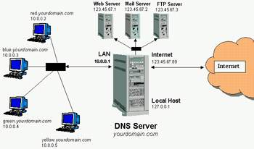

It is a hierarchical decentralized naming system for computer, services or other resources connected to the internet or a private network. It associates various information with domain names assigned to each of the participating entities.Keeping correct DNS information people can access the services that you want to share.

- Ethical Hacking:
This is identifying weakness in a computer systems or networks to exploit its weakness to gain access. Hackers break into the system and get access to all the information about the system.(though this method was not preferred while working on this project.)

- Using Credentials:
In a network established one can ping a system to get information about whether the host is up or not and its username and OS.But to access other information about the system one needs to login into that system using credentials. So this was this method was used. A group of people made another User: “ongc” with Password: “ongc”.Using these credentials we could access all the information using wmi commands.

V.Method

After creating another user: ongc with password:ongc one could remote access the systems. But there are certain set of setting to be changed to get access to other systems.
The commands that were used were “Windows Management Interface Commands”(wmic).
Using these commands one can acess any system in a network using credentials.
Eg: wmic computer system get manufacturer ;
The above command is used to get information about the manufacturer.
Likewise there are many other commands that were used to get information about the systems.
Though we could access information of our system but for accessing other system we need to change certain permissions of the systems to be accesed.They are:
- Firewall:
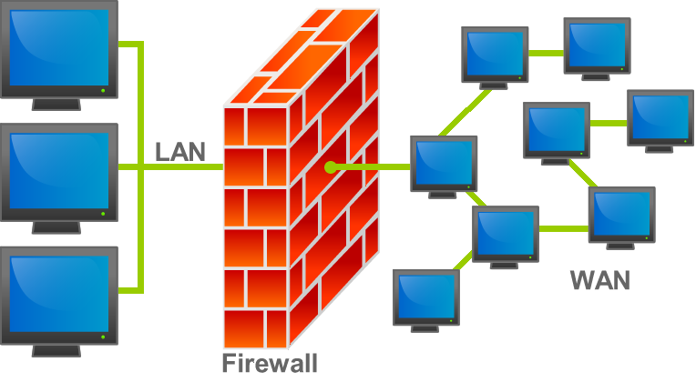
In computing, a firewall is a network security system that monitors and controls incoming and outgoing network traffic based on predetermined security rules.^{[1]} A firewall typically establishes a barrier between a trusted internal network and untrusted external network, such as the Internet.If the firewall is turned on then no system pinging the system will get a reply so the firewall of the system must be turned off while pinging the system to check of host is up.

- DCOMCNGF(Distributed component object model configuration)

The settings of dcom security are changed providing full writes for remote access and local acess.these are basically acess permissions and launch and activation permissions granted for complete access.
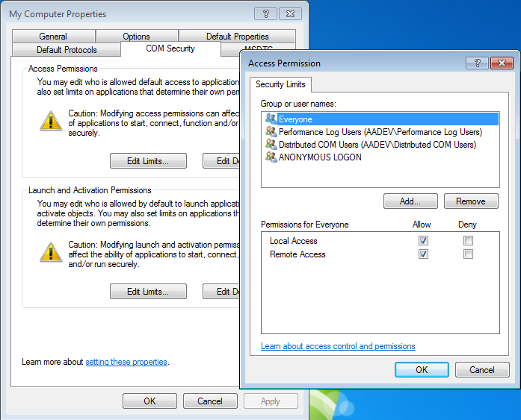

- WMIMGMT.MSC(wmi managementMicrosoftConsole)

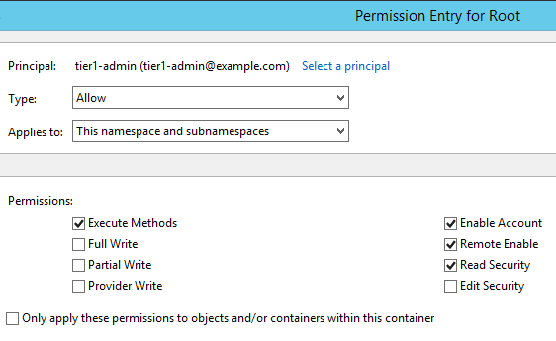

The permissions granted in dcomcnfg are again granted in wmimgmt.msc .In addition to it the namespace and subnamespace permission is granted such that to each type of setting that area added so that the command is recognised by different set of namespaces and subnamespaces in the command prompt window.

- User Account Control Settings

This setting is changed to “Never Notify” so that whenever in a network if a system pings another system the system does not have to wait for the system to grant permission again and again. Thus it basically avoids the permission prompt to appear again and again.
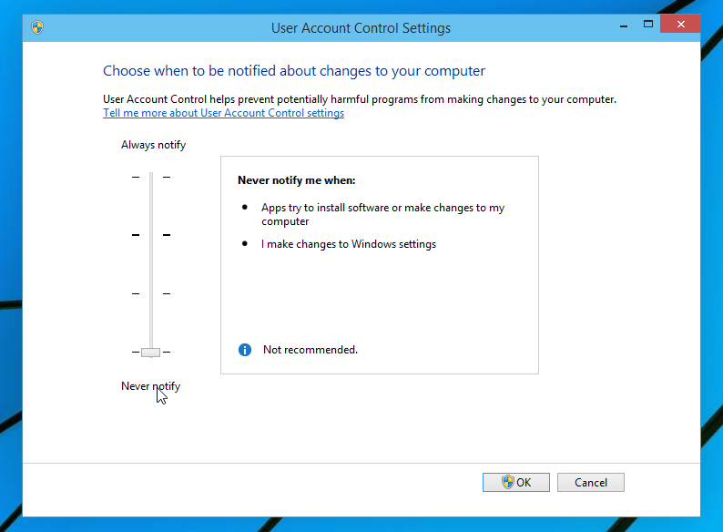

- Resources used

- PHP:

Hypertext Preprocessor (or simply PHP) is a server-side scripting language designed for Web development, but also used as a general-purpose programming language. It was originally created by Rasmus Lerdorf in 1994. The PHP reference implementation is now produced by The PHP Group. PHP originally stood for Personal Home Page, but it now stands for the recursive acronym PHP: Hypertext Preprocessor.
PHP is the base language used in the project for the backend development of the application. It also links the backend to the frontend. PHP also helps in connecting the devices in the network and handles permission obstacles and information retrieval for Windows using Powershell commands and for Linux using Linux terminal.

- HTML:

Hypertext Markup Language (HTML) is the standard markup language for creating web pages and web applications. With Cascading Style Sheets (CSS) and JavaScript, it forms a triad of cornerstone technologies for the World Wide Web.
In this project, HTML has been exclusively used to define the structure of the webpages and provide a base for the flow of the user experience. HTML, in addition to CSS, dictates how the user sees the frontend of the application and interact with various text, colour and image elements.

- CSS:

Cascading Style Sheets (CSS) is a style sheet language used for describing the presentation of a document written in a markup language like HTML. CSS is a cornerstone technology of the World Wide Web, alongside HTML and JavaScript.
In our work, we have used CSS to refine the styling and formatting of our web pages. CSS is extremely beneficial for introducing re-usability of code making it easier for us to keep a theme going as far as user interface is concerned.

- phpMyAdmin:

phpMyAdmin is a free and open source administration tool for MySQL and MariaDB. As a portable web application written primarily in PHP, it has become one of the most popular MySQL administration tools, especially for web hosting services.
This application has been exclusively used in this project for the creation and maintenance of database, operated using MySQL. The info table is used to maintain the details of all the system in the network, refreshing for every search. the table comes under the ongc database.the new systems discovered are simply added and no information is lost so that even if a host is down one can get information about the host.

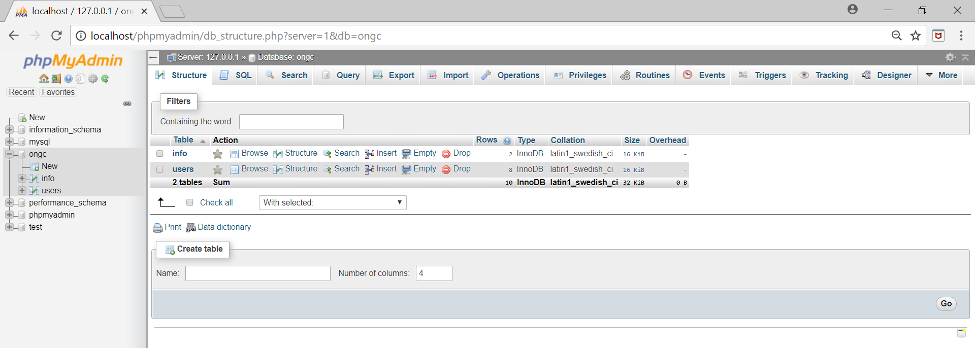

- XAMPP:

XAMPP is a free and open source cross-platform web server solution stack package developed by Apache Friends, consisting mainly of the Apache HTTP Server, MariaDB database, and interpreters for scripts written in the PHP and Perl programming languages. XAMPP stands for Cross-Platform (X), Apache (A), MariaDB (M), PHP (P) and Perl (P). It is a simple, lightweight Apache distribution that makes it extremely easy for developers to create a local web server for testing and deployment purposes. Everything needed to set up a web server – server application (Apache), database (MariaDB), and scripting language (PHP) – is included in an extractable file. XAMPP is also cross-platform, which means it works equally well on Linux, Mac and Windows. Since most actual web server deployments use the same components as XAMPP, it makes transitioning from a local test server to a live server extremely easy as well.

In our project, XAMPP has been simply used to activate application environment to support development of web application. These two applications are namely Apache and MySQL.

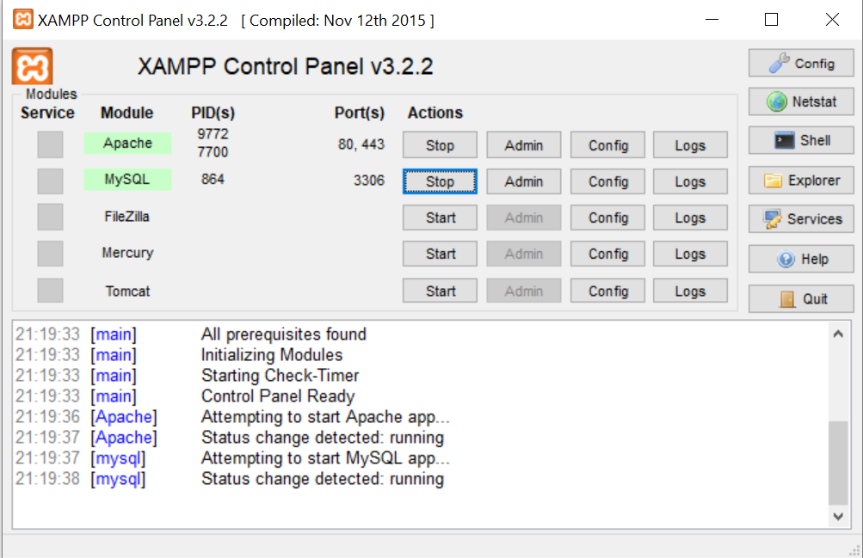

d. PuTTY:

PuTTY software is responsible for enabling SSH connection in Windows. SSH connection does not exist by default in Windows but is needed in this project to form a connection with Linux machines to retrieve the system information through a secure channel. Using putty and plink.exe which is installed with puTTY we can login to the root of the Linux and retrieve the information.
EG:
shell_exec ('plink.exe root@'.$ip.' -pw ongc123 -C "dmidecode -s system-manufacturer"');
The above command is used to login to root having password “ongc123” and then the dmidecode is used as wmic is used in windows to get information about the host.
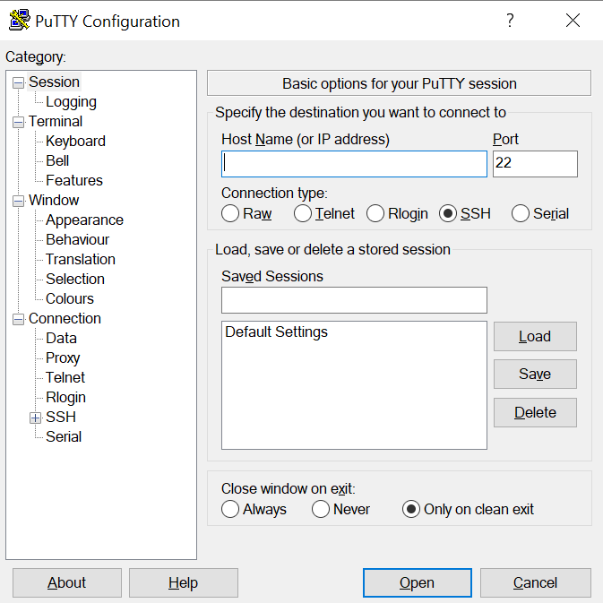

- Coding and output snippets

Given below is the code that performs the scan of given ip address range and stores the information in the table called info.

- Result.php:
This page displays all the system falling within the pre-received IP range. It shows introduction about each system and tells whether they are active or passive members in the network. It also presents the user with an option to view additional hardware and software details about the selected machine whether its Windows or Linux.
<?php
session_start();
$bool = true;

$con=mysqli_connect("localhost", "root", "","ongc") or die (mysql_error()); //Connect to server
mysqli_select_db($con,"ongc") or die ("Cannot connect to database"); //Connect to database

set_time_limit(0);
if (isset($_GET['iprange']))
{
$iprange = $_GET['iprange'];
}
else $iprange = "192.168.43.220-225";

$explodedarray =explode('-',$iprange) ;
$loopend = $explodedarray[1];

$explodedarray2 = explode('.' , $explodedarray[0]);
$ippart1 = $explodedarray2[0];
$ippart2 = $explodedarray2[1];
$ippart3 = $explodedarray2[2];
$loopbegin = $explodedarray2[3];

$i=$loopbegin;

for($i;$i<=$loopend;)
{
$ip = $ippart1.'.'.$ippart2.'.'.$ippart3.'.'.$i;
echo $ip.'</br>';
$query = 'ping -n 1'.' '.$ip;
//echo $query.'</br>';

$pingoutput = shell_exec($query);
$matchtext = "Pinging with 32 bytes of data:
Reply from : bytes=32 time< TTL=
Ping statistics for :
Packets: Sent = 1, Received = 1, Lost = 0 (0% loss),
Approximate round trip times in milli-seconds:
Minimum = 0ms, Maximum = 0ms, Average = 0ms";
similar_text($pingoutput, $matchtext, $percentage);

if ($percentage >=80)
//echo 'Host is up , IP address :'.$ip.'</br>';

$manufacturerquery = 'wmic /node:'.$ip.'/USER:"'.$ip.'\ongc" /PASSWORD:ongc computersystem get Manufacturer';
$usernamequery = 'wmic /node:'.$ip.'/USER:"'.$ip.'\ongc" /PASSWORD:ongc computersystem get username';
$osquery = 'wmic /node:'.$ip.'/USER:"'.$ip.'\ongc" /PASSWORD:ongc os get caption,version';
$drivequery = 'wmic /node:'.$ip.'/USER:"'.$ip.'\ongc" /PASSWORD:ongc memorychip get devicelocator , capacity';
$logicaldisk = 'wmic /node:'.$ip.'/USER:"'.$ip.'\ongc" /PASSWORD:ongc logicaldisk get name,filesystem';
$printer = 'wmic /node:'.$ip.'/USER:"'.$ip.'\ongc" /PASSWORD:ongc printer get name,deviceid';
$printjob = 'wmic /node:'.$ip.'/USER:"'.$ip.'\ongc" /PASSWORD:ongc printerjob get document,description';
$cpu = 'wmic /node:'.$ip.'/USER:"'.$ip.'\ongc" /PASSWORD:ongc cpu get Name, Caption, MaxClockSpeed';
$serialno = 'wmic /node:'.$ip.'/USER:"'.$ip.'\ongc" /PASSWORD:ongc os get serialnumber';

$manufacturerqueryshell = shell_exec($manufacturerquery);
if(strlen($manufacturerqueryshell)==4){

$manufacturerqueryshell = shell_exec('plink.exe root@'.$ip.' -pw ongc123 -C "dmidecode -s system-manufacturer"');
}

$usernameshell = shell_exec($usernamequery);
if(strlen($usernameshell)==4){
$usernameshell=shell_exec('plink.exe root@'.$ip.' -pw ongc123 -C "whoami"');
}
$osqueryshell=shell_exec($osquery); if(strlen($osqueryshell)==4){
$osqueryshell=shell_exec('plink.exe root@'.$ip.' -pw ongc123 -C "lsb_release -a"');
}$drivequeryshell=shell_exec($drivequery);
if(strlen($drivequeryshell)==4){
$drivequeryshell='<pre>'.shell_exec('plink.exe root@'.$ip.' -pw ongc123 -C "free"').'</pre>';
}
$logicaldiskshell=shell_exec($logicaldisk);
$printershell = shell_exec($printer);
$printjobshell= shell_exec($printjob);
$cpushell=shell_exec($cpu);
if(strlen($cpushell)==4){
$cpushell='<pre>'.shell_exec('plink.exe root@'.$ip.' -pw ongc123 -C "dmidecode -s processor-version"').'</pre>';
}
$serialnumbershell=shell_exec($serialno);
if(strlen($serialnumbershell)==4){ $serialnumbershell='<pre>'.shell_exec('plink.exe root@'.$ip.' -pw ongc123 -C "dmidecode -s system-serial-number"').'</pre>';

}

$insertquery = mysqli_query($con,"INSERT INTO info (`ip`, `manufacturer`,`hostname`, `os`, `processor`, `ram`,`localdd`,`printer`,`ssn`,`updown`,`uid`)
VALUES('$ip','$manufacturerqueryshell','$usernameshell','$osqueryshell','$cpushell','$drivequeryshell','$logicaldiskshell', '$printershell','$serialnumbershell','UP','')");

else if($percentage<80)
{
Echo “host is down;
}

$i=$i+1;
}//for loop ends

?>

The followings are a few snippets of the graphical user interface of the application.

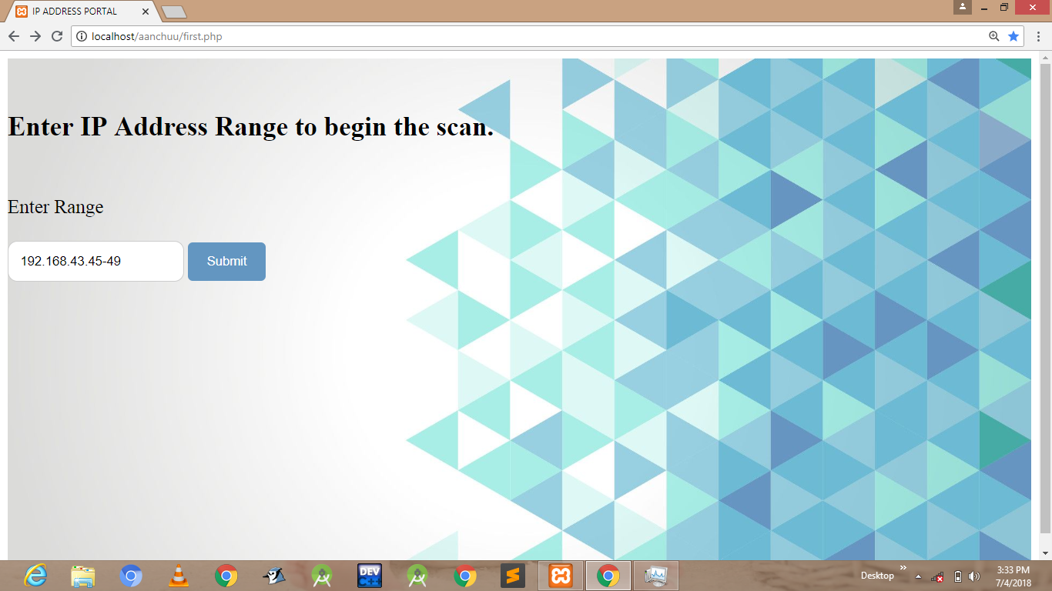
Fig 3. first.php

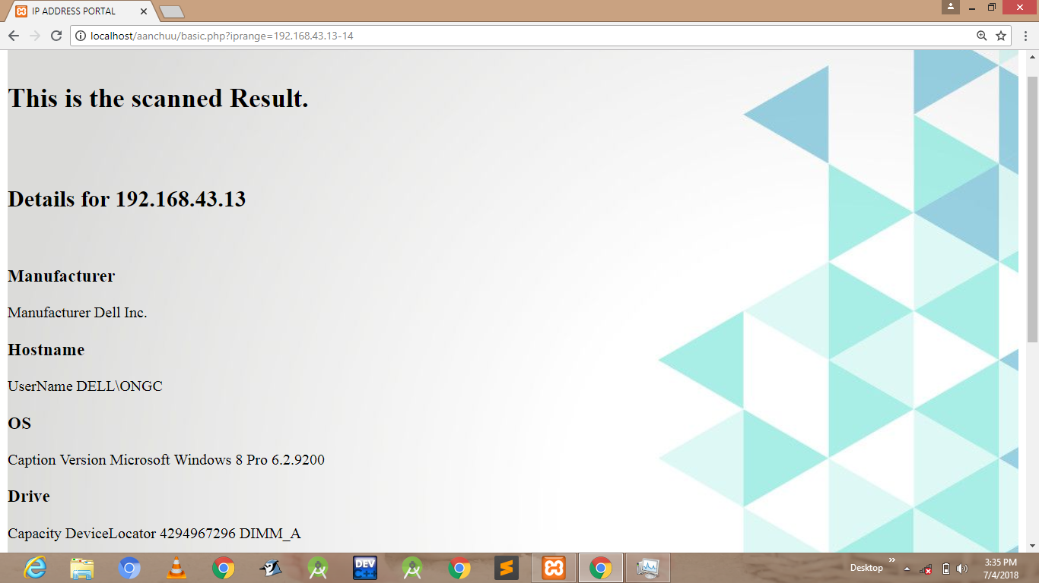
Fig 4. result.php

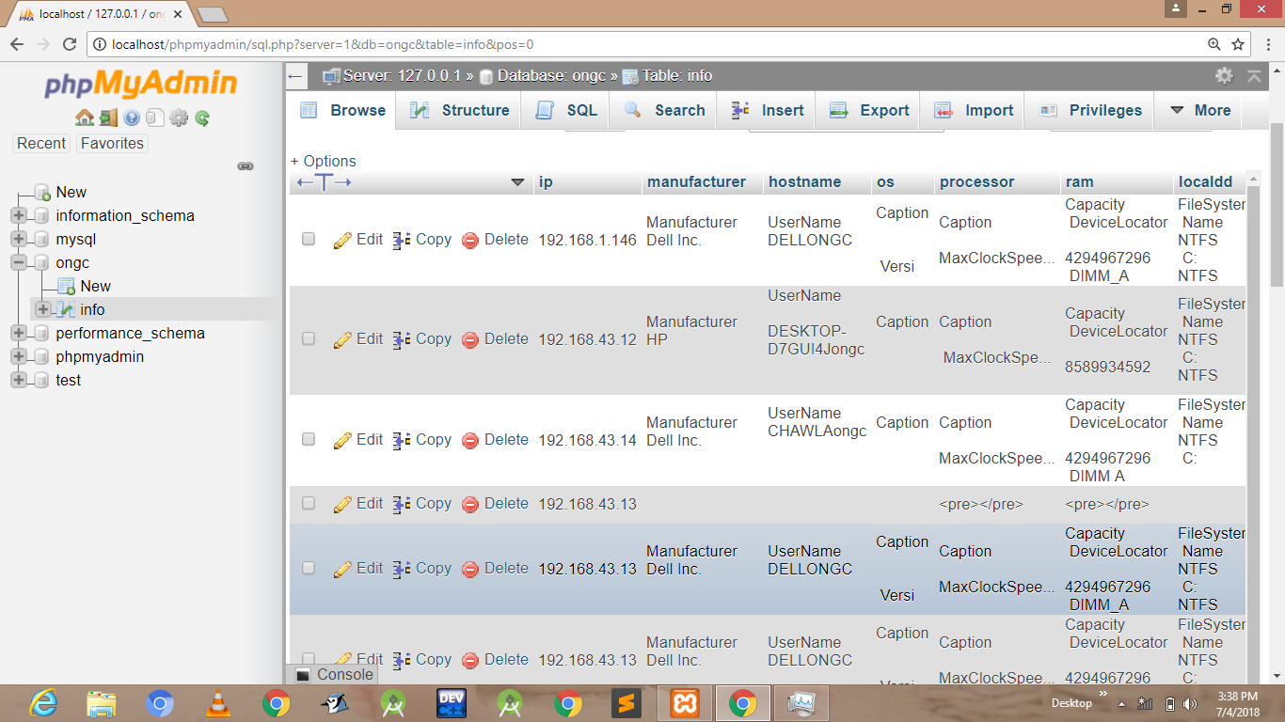
Fig 5. Info table

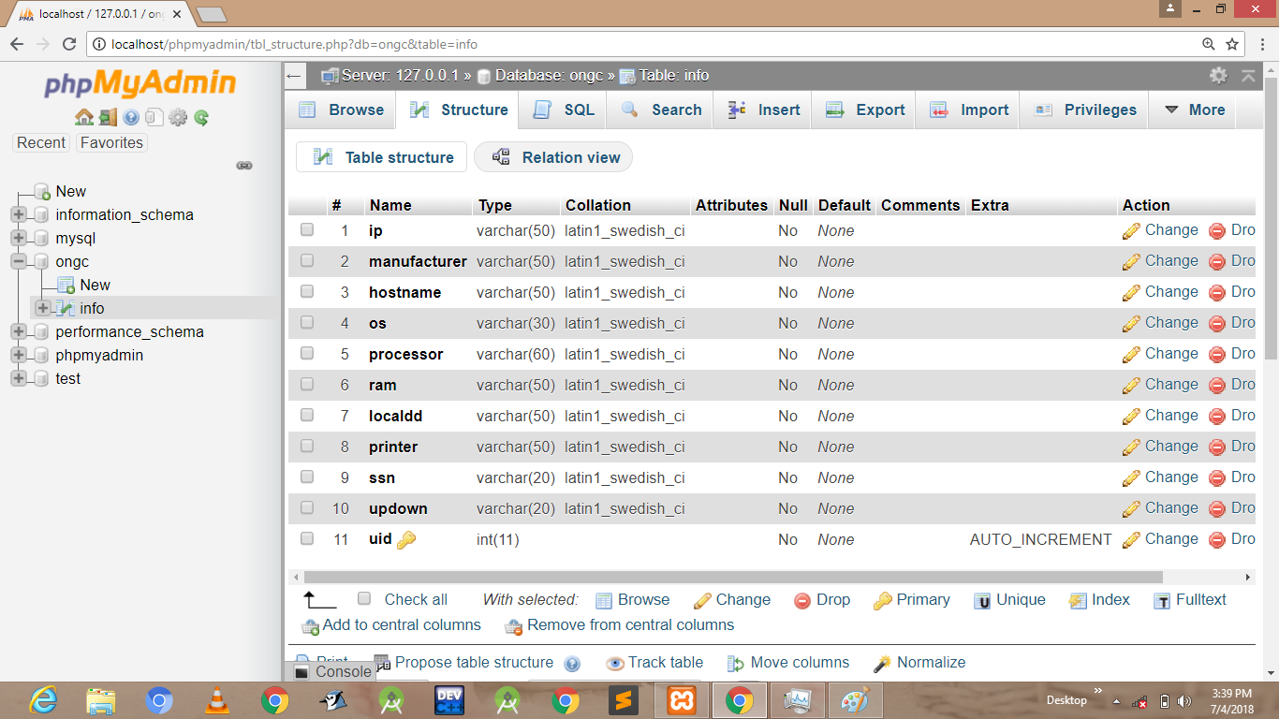

Schema for the info table.

- Conclusion

This application was successful in this objective of identifying IT assets in a company. With the increasing amount of fortune spent on employing systems and sub-systems it becomes pertinent and absolutely essential to keep a tab on the credentials of these assets, especially when they are interconnected in a network over internet or otherwise. This application will be particularly useful in scenarios like these.

Although this application is self-sufficient and efficient in its operation, it can be improved in several different ways, such as the user experience can be smoothened, the login -logout system can be included better servers can be employed etc. These changes can be brought about in the coming versions of this application. The current version identifies Windows, Linux and can be made to identify other operating systems.
This application will work on windows a working model for Linux can also be constructed.
One more drawback in this application is one needs to check its own ip address to retrieve its own information as set of commands are different for remote access and local access so it can be made better if the application itself realizes the difference between the host machine and its own system.

